**NodePort service:**

* We can use nodeport expose the pod to outside world.

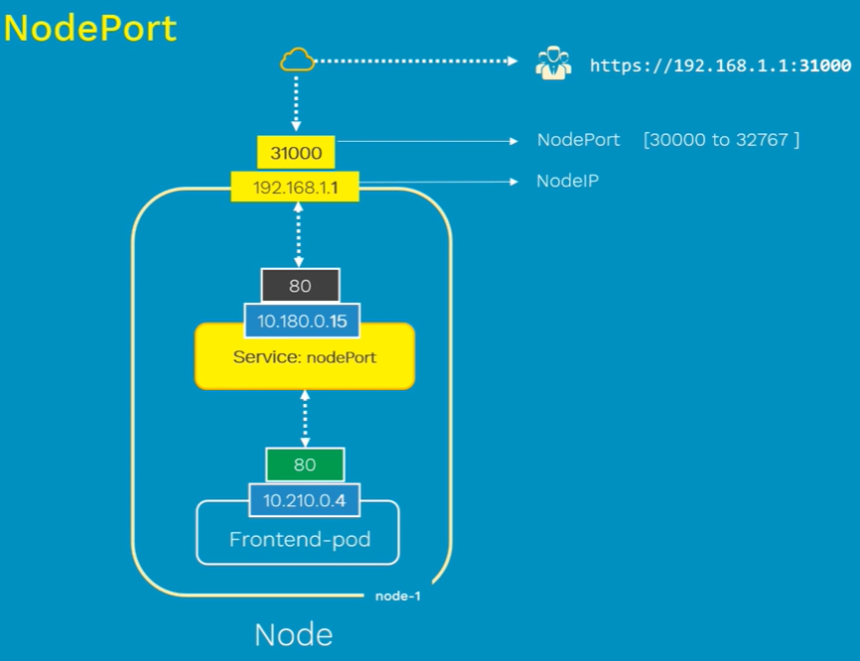

* As above, we use the node IP to expose the service to outside
* We also need to provide the nodeport in manifest file ranging between 30000 and 32767. If we don’t mention, kubenetes will take the any free port available in cluster.

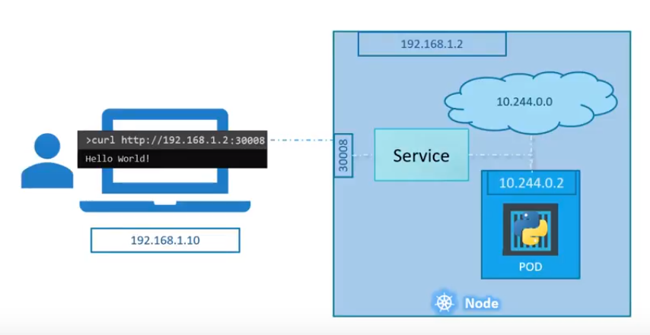

**Port types:**

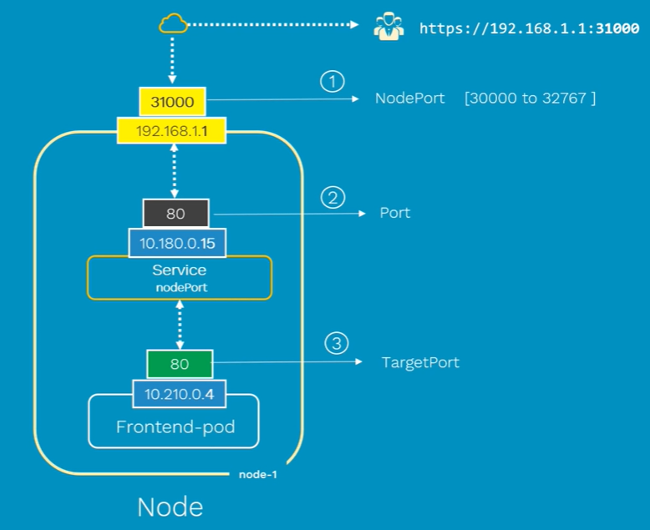

* Node port is at the node level assigns to node IP
* Port is the service port that connects to target port of pod. Port and target port will be same.

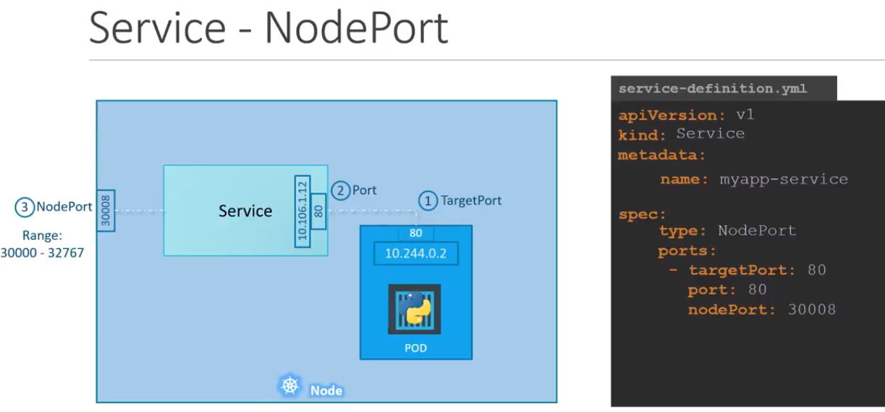

**Multiple instance in same node:**

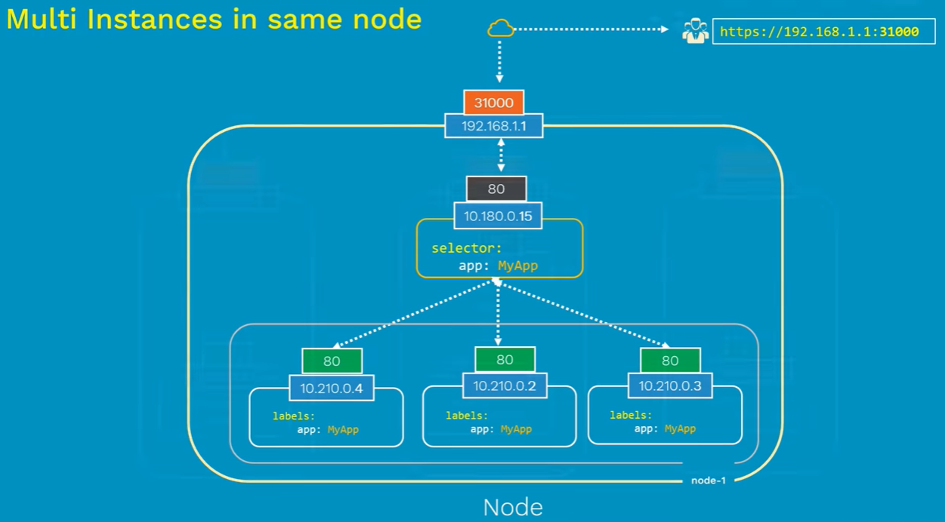

**Multiple instances in different nodes:**

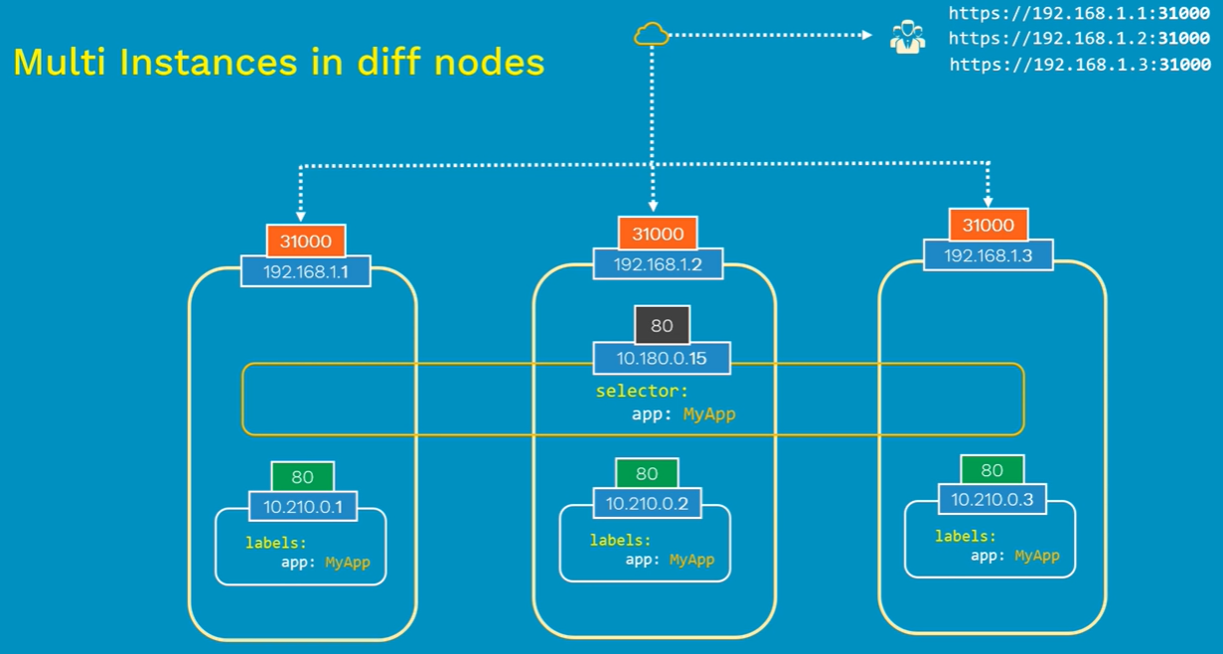

**Downsides:**

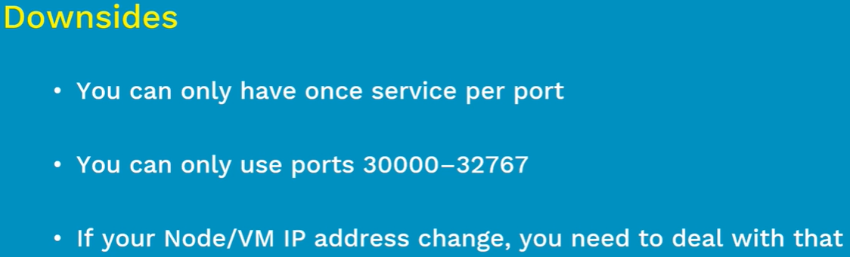

Because of these downsides, nodeport is not recommended.

**Manifest file:**

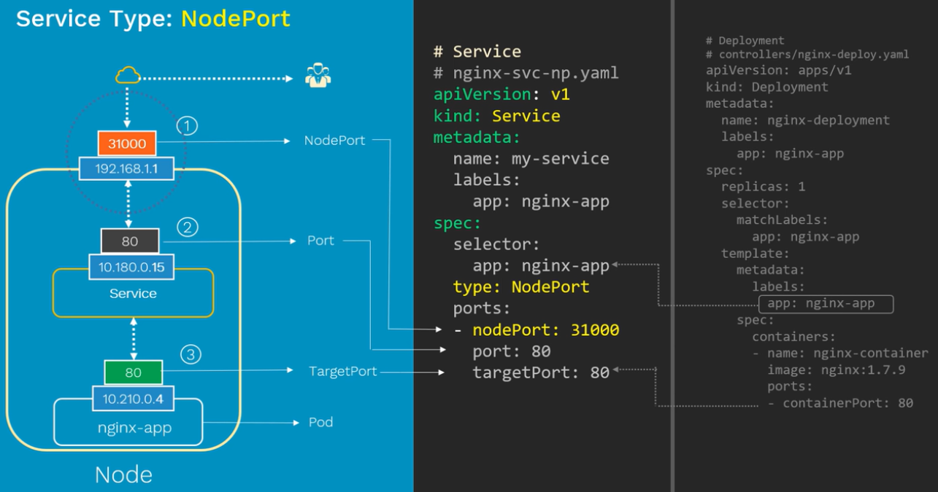

**We can also define the protocol in yaml file as below. By default, it is TCP only**

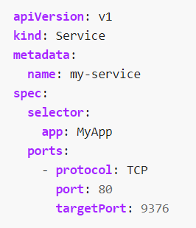

**Multiple port services:**

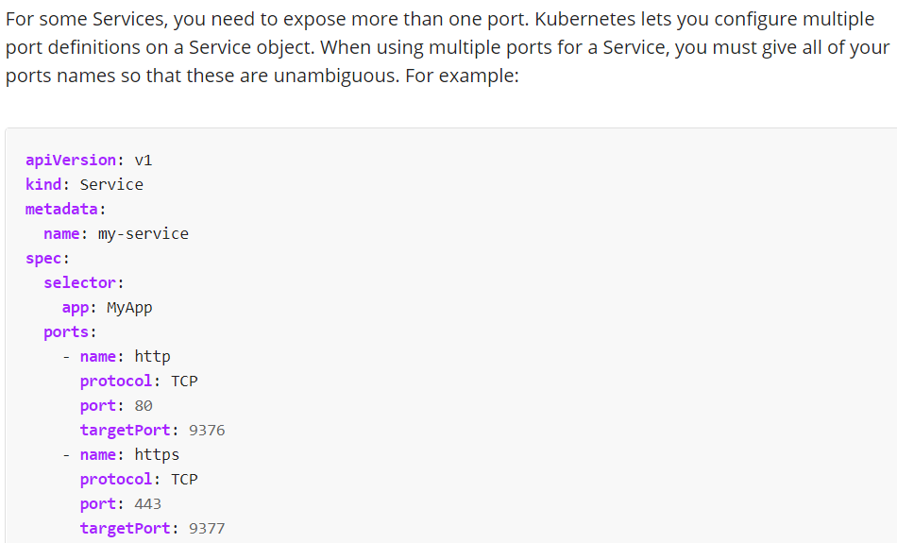

**Service without selectors:**

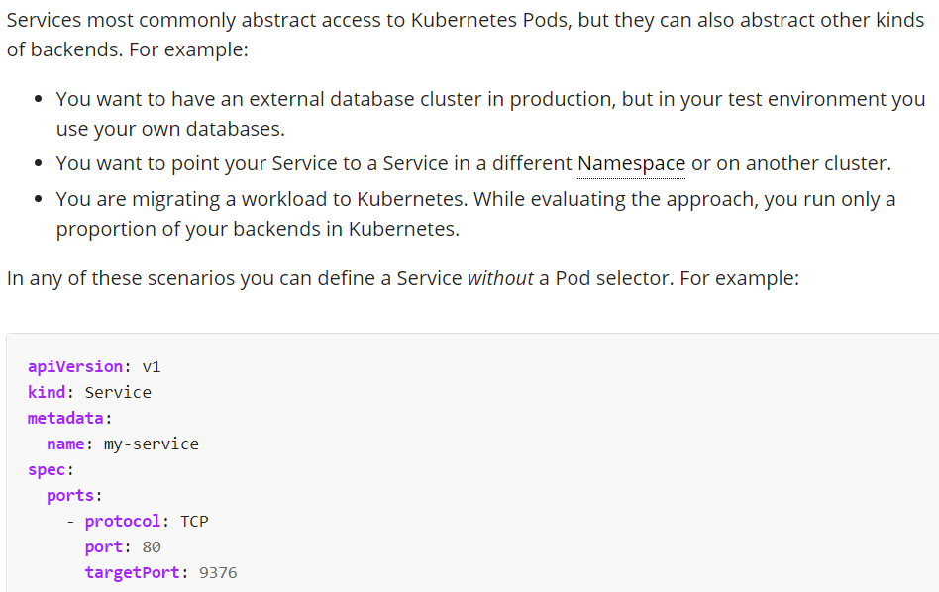

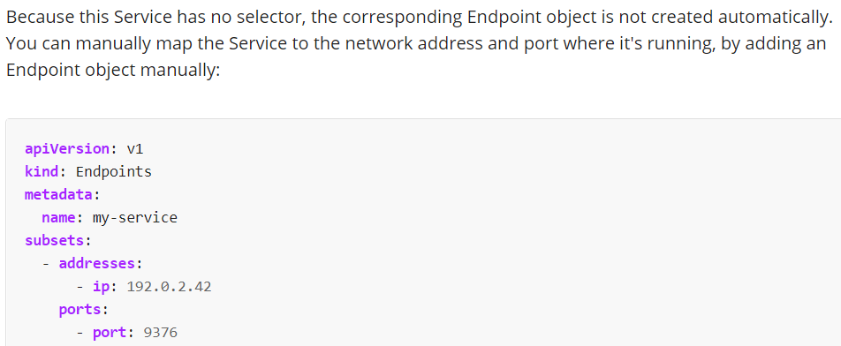

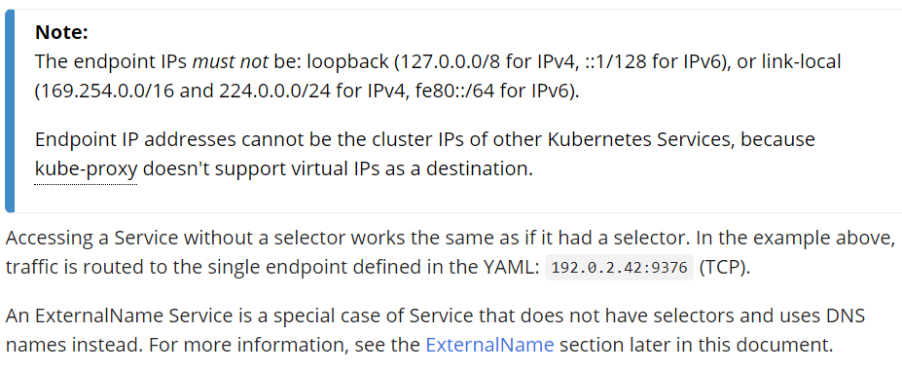

**Create & display:**

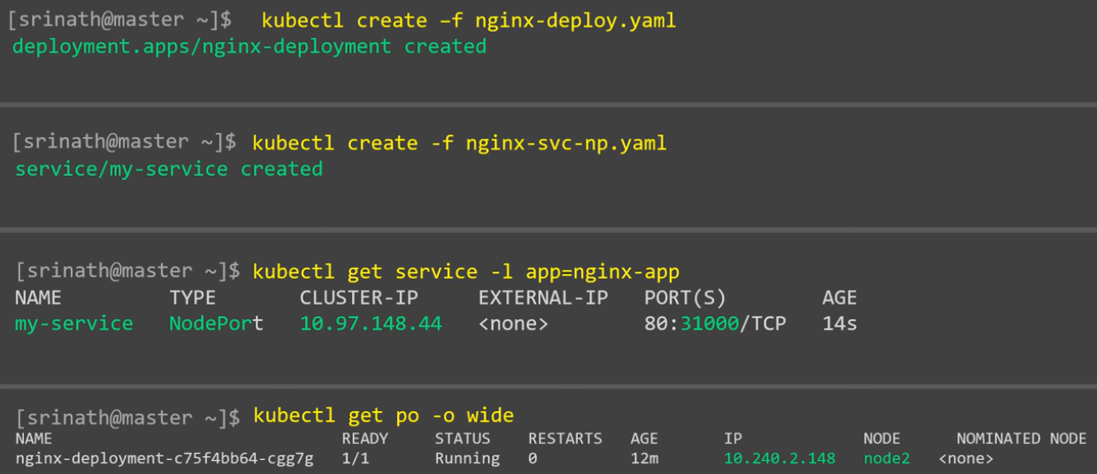

**Describe:**

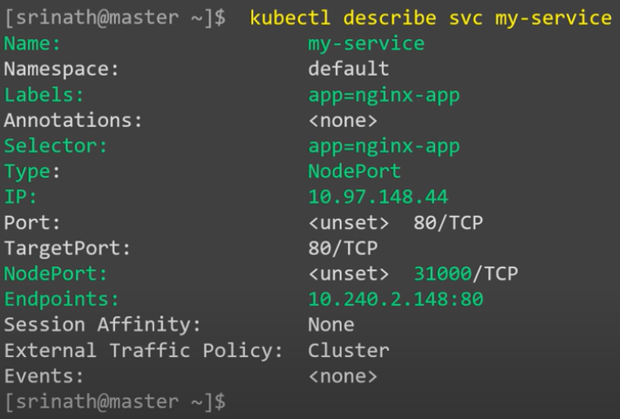

* As above, we can see the service IP, nodeport, target port and port of service
* Endpoint means the pod IP with port.

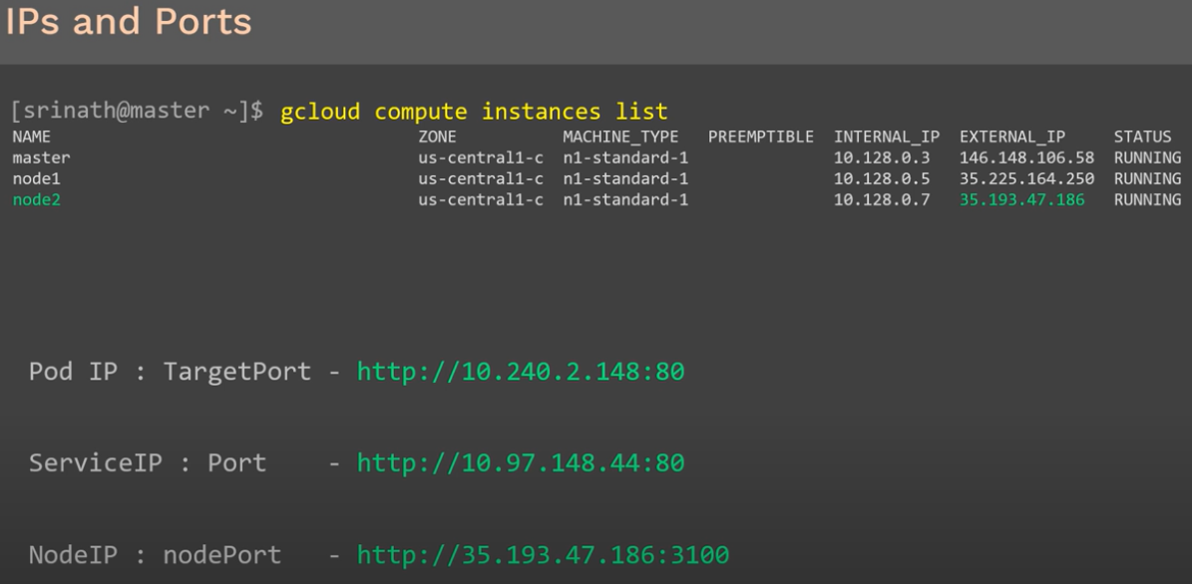

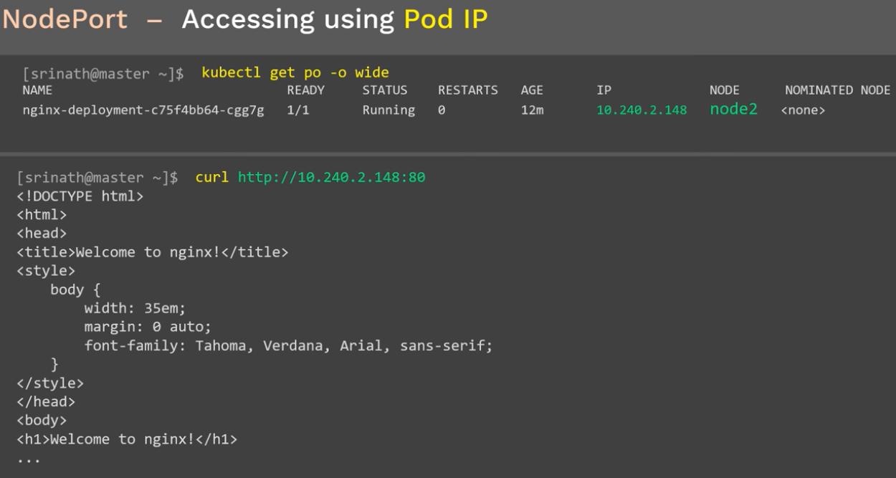

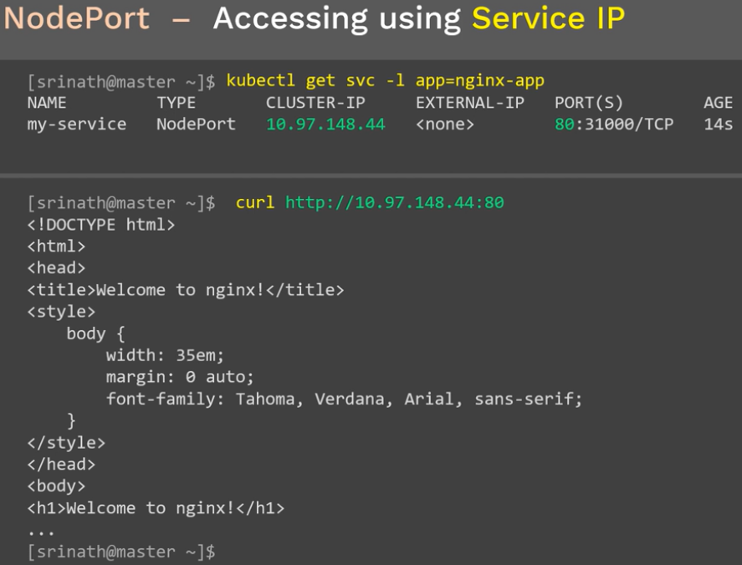

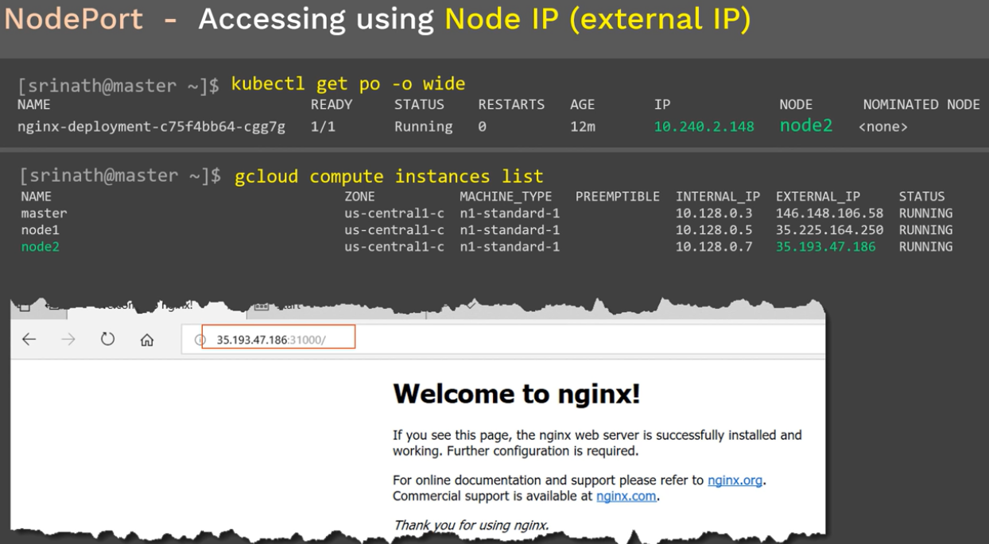

**Cleanup:**

* Pods will be deleted if we delete the service.

